Intraday Liquidity Regimes in Indian Equities
Abstract
This paper studies the structure and evolution of intraday liquidity in Indian equities using ten years of 5-minute data for NIFTY 500 stocks from 2015 to 2025. Rather than assuming a universal U-shaped intraday trading pattern, we identify distinct and persistent intraday liquidity regimes based on the temporal distribution of trading volume. Using unsupervised clustering techniques, we document three economically interpretable regimes: open-dominated, flat liquidity, and close-dominated.
We show that the prevalence of these regimes has undergone a pronounced structural shift since 2019, with a sharp decline in close-dominated liquidity and a substantial rise in flat and open-dominated regimes. This transformation persists within market capitalization buckets and is robust to alternative specifications, indicating that it is not driven solely by changes in index composition or firm size. Stress-day analysis reveals that periods of elevated volatility are associated with a systematic reallocation of liquidity toward the market open, consistent with heightened execution urgency and risk aversion later in the trading session.
We further demonstrate that liquidity regimes have economically meaningful implications for execution costs and price dynamics. Flat liquidity regimes exhibit the lowest simulated VWAP slippage, while close-dominated regimes render participation-constrained VWAP execution infeasible. In addition, close-dominated stocks display the strongest short-horizon return reversals, consistent with concentrated non-informational trading pressure near the market close.
Overall, our findings provide new evidence on the evolution of intraday liquidity in an emerging market, highlighting the growing importance of continuous execution and the declining dominance of end-of-day trading concentration. The results have direct implications for execution strategy design, intraday risk management, and market microstructure modeling.

1. Introduction
Intraday liquidity plays a central role in financial market functioning, affecting price discovery, execution costs, volatility dynamics, and market stability. A well-established finding in market microstructure is that trading activity follows a U-shaped pattern over the trading day, with heightened volume and volatility at the open and close and relatively subdued activity mid-session. This stylized fact has been documented extensively for developed markets and is often treated as a stable and universal feature of equity trading.
However, the assumption of a single, homogeneous intraday liquidity pattern masks substantial heterogeneity in trading behavior across stocks and over time. In particular, the rapid growth of electronic trading, algorithmic execution, and institutional participation has altered how liquidity is supplied and consumed within the trading day. These changes may be especially pronounced in emerging markets, where market structure, investor composition, and technological adoption have evolved rapidly over the past decade.
This paper revisits intraday liquidity patterns in Indian equities through the lens of liquidity regimes rather than a single representative curve. Using ten years of high-frequency data for the NIFTY 500 universe, we ask three related questions. First, do Indian equities exhibit distinct and persistent intraday liquidity regimes? Second, how have these regimes evolved over time, particularly around the period of rapid electronic adoption and the COVID-19 market disruption? Third, do these regimes have meaningful implications for execution costs and short-horizon price dynamics?
To address these questions, we construct normalized intraday volume profiles using 5-minute OHLCV data and apply unsupervised clustering techniques to identify common liquidity structures. This approach allows us to focus on the shape of intraday liquidity rather than its level, enabling meaningful comparison across stocks with vastly different trading intensities. We identify three dominant regimes: open-dominated liquidity, characterized by a strong concentration of trading activity early in the session; flat liquidity, in which volume is distributed relatively evenly throughout the day; and close-dominated liquidity, where trading is heavily concentrated near the market close.
Our results reveal a pronounced structural transformation in intraday liquidity since 2019. The share of close-dominated stocks declines sharply over the sample period, while flat and open-dominated regimes become increasingly prevalent. Importantly, this shift persists within large-, mid-, and small-capitalization buckets and is strongly statistically significant, indicating that it is not driven solely by changes in market capitalization composition or index membership. Stress-day analysis further shows that elevated market volatility is associated with a systematic reallocation of liquidity toward the market open, suggesting that execution urgency and risk management considerations play a key role in shaping intraday trading patterns.
Beyond documenting liquidity regimes, we examine their economic relevance. Using a participation-constrained VWAP execution framework, we show that flat liquidity regimes are associated with the lowest simulated execution costs, while close-dominated regimes render VWAP execution infeasible due to extreme end-of-day concentration. We also study regime-conditional return dynamics and find that close-dominated stocks exhibit the strongest short-horizon return reversals, consistent with concentrated non-informational trading pressure related to inventory management, benchmarking, and index tracking near the close.
This paper contributes to the literature in several ways. First, it provides the first large-scale, high-frequency evidence on intraday liquidity regimes in Indian equities using a broad cross-section of stocks over a long horizon. Second, it documents a structural evolution in intraday liquidity that parallels the maturation of electronic and algorithmic trading in an emerging market setting. Third, it links liquidity regimes to execution feasibility and short-horizon price behavior, offering practical insights for traders, asset managers, and regulators.
The remainder of the paper proceeds as follows. Section 2 describes the data and construction of intraday liquidity measures. Section 3 outlines the clustering methodology and identifies intraday liquidity regimes. Section 4 analyzes the evolution, persistence, and stress-day behavior of these regimes. Section 5 examines execution cost implications and regime-conditional return dynamics. Section 6 concludes.
2. Data and Methodology
2.1 Data
Our empirical analysis is based on intraday data for stocks in the NIFTY 500 index over the period January 2015 to March 2025. The dataset consists of 5-minute OHLCV (Open, High, Low, Close, Volume) observations for each stock, covering the full regular trading session on the National Stock Exchange of India. This frequency provides a balance between capturing intraday microstructure dynamics and maintaining robustness to microstructure noise associated with ultra-high-frequency data.
To avoid survivorship bias, we construct the universe using historical index membership, allowing stocks to enter and exit the sample according to their actual inclusion in the NIFTY 500 over time. Corporate actions such as stock splits and bonus issues are adjusted using standard price adjustment factors. Days with incomplete trading sessions or exchange-wide halts are excluded.
The final sample contains approximately 75 intraday intervals per trading day per stock, yielding over 300 million 5-minute observations across the full sample period.

2.2 Construction of Intraday Liquidity Profiles
Our objective is to study the temporal allocation of liquidity within the trading day, rather than absolute trading intensity. To make intraday patterns comparable across stocks with vastly different levels of activity, we normalize intraday volume at the daily level.
For stock $i$, day $d$, and intraday interval $t$, we define the intraday volume share as:
$$V_{i,d,t}^{*}=\frac{V_{i,d,t}}{\sum_{t=1}^{T}{V_{i,d,t}}},$$
where $V_{i,d,t}$denotes traded volume and $T$is the number of 5-minute intervals in the trading day.
This normalization ensures that each stock-day profile sums to one, allowing the analysis to focus on when trading occurs during the day rather than how much trading occurs.
For each stock and calendar year, we compute the average intraday volume profile by averaging $V_{i,d,t}^{*}$across all trading days in that year. The resulting profile is a fixed-length vector representing the typical intraday liquidity shape for a given stock-year.

2.3 Feature Engineering: Liquidity Shape Measures
To characterize intraday liquidity profiles in a parsimonious and economically interpretable manner, we extract a set of summary features capturing timing asymmetry and concentration:
- Open intensity: cumulative volume share during the first 30 minutes of trading
- Close intensity: cumulative volume share during the last 30 minutes of trading
- Midday share: cumulative volume share during the middle portion of the session
- U-shape strength: defined as
$$U_{i}=(Open_{i}+Close_{i})-Midday_{i}$$
- Entropy of volume distribution, capturing fragmentation versus concentration
- Peak concentration index, measuring maximum single-interval dominance
These features jointly summarize whether trading activity is front-loaded, back-loaded, evenly distributed, or sharply concentrated.
Each observation in the clustering analysis corresponds to a stock–year liquidity profile, represented by this feature vector.

2.4 Identification of Intraday Liquidity Regimes
We identify intraday liquidity regimes using unsupervised clustering applied to the feature vectors described above. Prior to clustering, all features are standardized to have zero mean and unit variance.
Our baseline specification uses k-means clustering, with the number of clusters selected based on a combination of silhouette scores, cluster interpretability, and stability under bootstrap resampling. This procedure consistently yields three dominant clusters, which we interpret as distinct intraday liquidity regimes.
To validate cluster quality and robustness, we report:
- average silhouette scores,
- bootstrap cluster stability,
- principal component projections for visualization.
The resulting regimes are labeled based on their dominant characteristics:
- Open-Dominated Liquidity
- Flat Liquidity
- Close-Dominated Liquidity

2.5 Regime Evolution and Transition Analysis
To study the evolution of liquidity regimes over time, we track the distribution of regimes across years and conduct chi-squared tests to assess whether regime shares differ significantly across subperiods. We focus in particular on the pre-2019, transition, and post-COVID periods.
We further analyze regime persistence and transitions by constructing year-over-year transition matrices. For each stock, we record its regime assignment in consecutive years and estimate transition probabilities across regimes. This allows us to assess regime stability and the directionality of structural change.

2.6 Stress-Day Identification
To examine how intraday liquidity responds to market stress, we classify stress days as those falling in the top 5% of daily realized volatility for the NIFTY 500 index. We then compare intraday volume profiles on stress days to those on normal days, focusing on shifts in open and close concentration.

2.7 Execution Cost Simulation
To assess the economic relevance of liquidity regimes, we conduct a VWAP execution cost simulation using 5-minute prices and volumes. For each stock-day, we simulate a participation-constrained VWAP execution strategy subject to realistic volume participation limits.
Execution cost is measured as the deviation between the simulated execution price and the arrival price. We additionally decompose costs into early impact and close risk components to capture regime-specific execution frictions.
For stocks with extreme end-of-day liquidity concentration, participation constraints may render VWAP execution infeasible; such cases are explicitly identified and analyzed.

2.8 Regime-Conditional Return Dynamics
Finally, we examine whether liquidity regimes are associated with differences in short-horizon price behavior. Using pooled intraday returns, we compute:
- lag-1 return autocorrelations,
- extreme reversal frequencies following large price moves,
separately for each liquidity regime. This analysis allows us to link intraday liquidity structure to temporary price pressure and return reversals.

2.9 Robustness Checks
We conduct several robustness checks to validate our findings:
- regime distributions within market capitalization buckets,
- out-of-sample stability tests using pre-2019 training and post-2019 assignment,
- alternative liquidity proxies based on intraday volatility shares.
Across specifications, the identified liquidity regimes and their economic implications remain stable.
3. Intraday Liquidity Regimes: Identification and Characteristics
3.1 Overview
This section identifies and characterizes distinct intraday liquidity regimes in Indian equities. Rather than imposing a priori assumptions about the shape of intraday trading activity, we use a data-driven approach to classify stocks based on the temporal distribution of trading volume within the day. The objective is to determine whether common and persistent liquidity structures exist across stocks, and whether these structures are economically interpretable.
Using normalized intraday volume profiles constructed from 5-minute data, we find strong evidence of three distinct intraday liquidity regimes. These regimes differ markedly in the timing and concentration of trading activity and account for substantial heterogeneity across the NIFTY 500 universe.

3.2 Clustering Results
We apply k-means clustering to stock–year intraday liquidity feature vectors, as described in Section 2. The number of clusters is selected based on a combination of silhouette scores, economic interpretability, and stability under bootstrap resampling.
The clustering procedure consistently yields three dominant clusters, with an average silhouette score of 0.262, indicating moderate but meaningful separation given the high dimensionality and noisy nature of intraday financial data. Bootstrap resampling confirms that cluster assignments are stable, with a mean stability score of 0.255 ± 0.010.
Regime prevalence
Across the full sample period, the three regimes account for the following shares of stock–year observations:
Liquidity Regime | Share of Observations
Flat Liquidity | 56%
Close-Dominated | 28%
Open-Dominated | 16%
These proportions already suggest that a majority of stocks do not conform to a strongly U-shaped liquidity pattern, motivating a closer examination of regime characteristics.

3.3 Intraday Volume Profiles by Regime
Figure 1 plots the average intraday volume share for each liquidity regime.
Open-Dominated Liquidity
Stocks in the open-dominated regime exhibit a pronounced concentration of trading activity at the start of the trading session. On average, more than 20% of daily volume is traded within the first 30 minutes, followed by a rapid decline in activity and relatively subdued trading for the remainder of the day.
This profile is consistent with front-loaded execution, potentially reflecting early information arrival, overnight risk resolution, and aggressive order placement by informed or time-sensitive traders.
Flat Liquidity
The flat liquidity regime is characterized by a relatively uniform distribution of trading volume throughout the day. Both open and close periods account for comparable shares of volume, with no single interval dominating the intraday profile.
This regime is indicative of continuous execution, commonly associated with algorithmic trading strategies such as VWAP and TWAP that aim to minimize market impact by smoothing execution over time.
Close-Dominated Liquidity
Close-dominated stocks display a strong concentration of trading activity near the end of the trading session. In these stocks, more than 25% of daily volume is executed during the final 30 minutes, while early-session activity is comparatively muted.
Such patterns are consistent with benchmark-driven trading, inventory rebalancing, and index tracking behavior, where execution is deliberately deferred toward the market close.
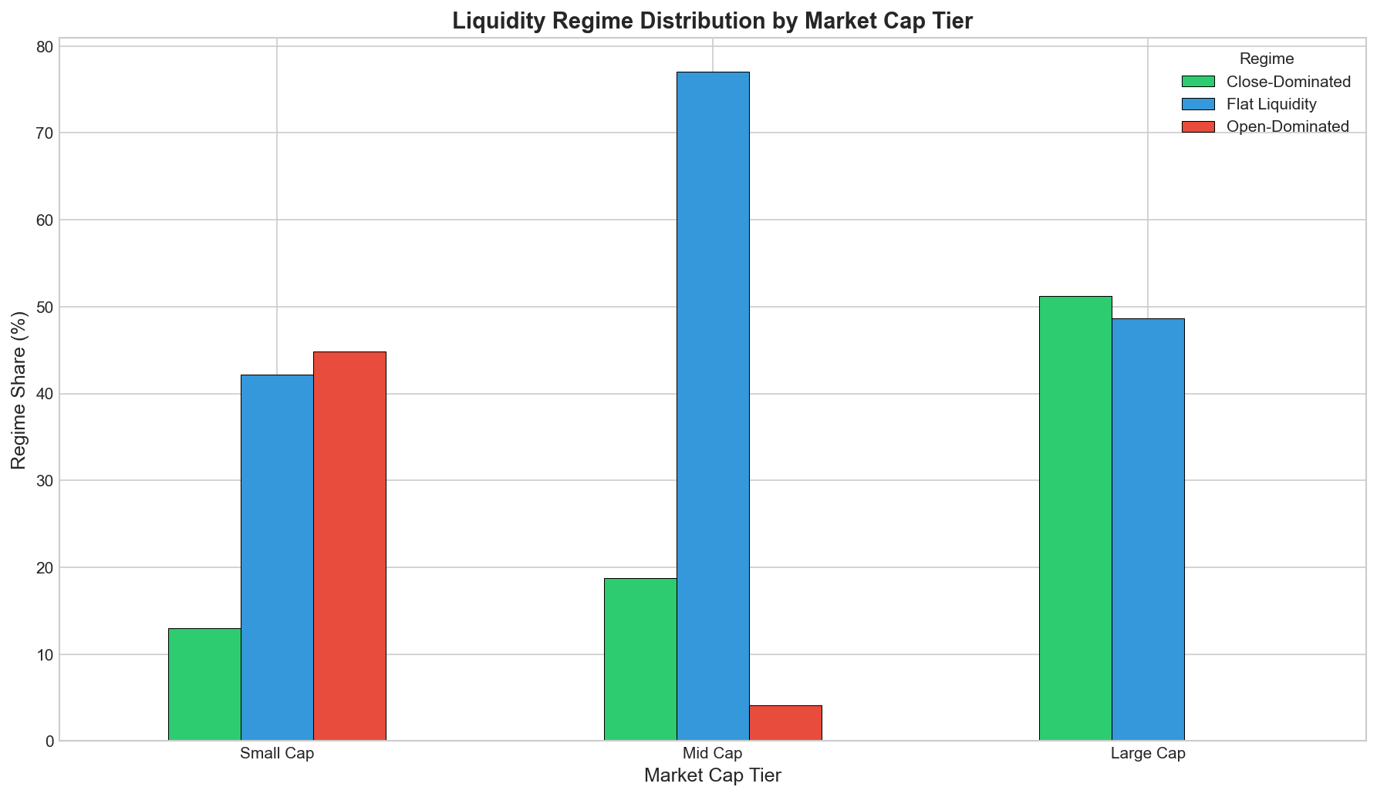

3.4 Principal Component Analysis
To further understand the structure of intraday liquidity profiles, we perform a principal component analysis (PCA) on the standardized feature vectors. Figure 2 presents the projection of observations onto the first two principal components.
The first principal component (PC1), explaining 46.5% of total variance, primarily captures timing asymmetry between open- and close-dominated trading. Observations with high PC1 values correspond to open-heavy profiles, while low values reflect close-heavy profiles.
The second principal component (PC2), accounting for 23.4% of variance, reflects dispersion and fragmentation, distinguishing sharply concentrated profiles from more evenly distributed ones.
The clear separation of regimes in PCA space provides additional validation that the identified clusters reflect meaningful structural differences rather than noise-driven artifacts.
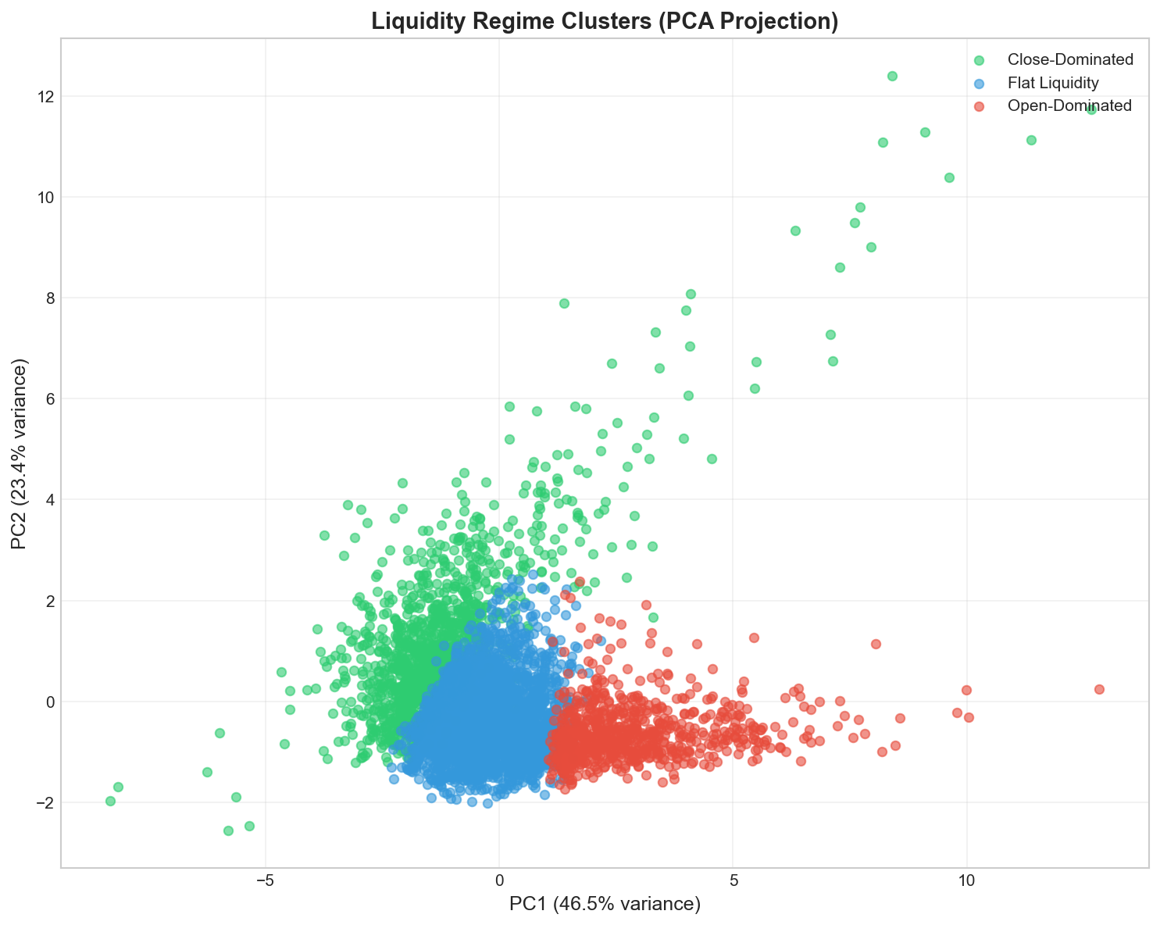

3.5 Economic Interpretation of Liquidity Regimes
The three liquidity regimes correspond closely to well-established microstructure mechanisms:
- Open-Dominated Liquidity is consistent with information-driven and urgency-based trading, where participants seek rapid execution early in the session.
- Flat Liquidity reflects execution optimization and algorithmic trading, emphasizing low market impact and continuous participation.
- Close-Dominated Liquidity aligns with non-informational trading motives, including benchmarking, index replication, and inventory management.
Importantly, these regimes are not mutually exclusive in theory but represent dominant patterns that persist at the stock–year level.

3.6 Summary
This section establishes that intraday liquidity in Indian equities is best described by a small number of persistent and economically interpretable regimes rather than a single universal U-shaped pattern. The existence of these regimes provides a foundation for the subsequent analysis of their evolution over time, their behavior during periods of market stress, and their implications for execution costs and short-horizon price dynamics.
4. Evolution, Structural Change, and Stress-Day Behavior of Liquidity Regimes
4.1 Time Evolution of Liquidity Regimes
Having established the existence of distinct intraday liquidity regimes, we next examine how their prevalence has evolved over time. Figure 3 plots the annual distribution of liquidity regimes across the NIFTY 500 universe from 2015 to 2025.
The results reveal a pronounced and systematic restructuring of intraday liquidity over the sample period. In the early years of the sample, intraday trading activity is dominated by the close-dominated regime, which accounts for nearly 58% of stock–year observations in 2015. By contrast, open-dominated liquidity is almost absent during this period.
Beginning around 2019, the composition of liquidity regimes shifts markedly. The share of close-dominated stocks declines steadily, while flat liquidity becomes the dominant regime. Following the COVID-19 market disruption, the open-dominated regime expands rapidly, accounting for more than one-third of observations by 2024. By the end of the sample, close-dominated liquidity represents less than 15% of the universe.
These patterns indicate that the traditional concentration of trading activity near the market close has weakened substantially, giving way to more continuous and front-loaded execution styles. 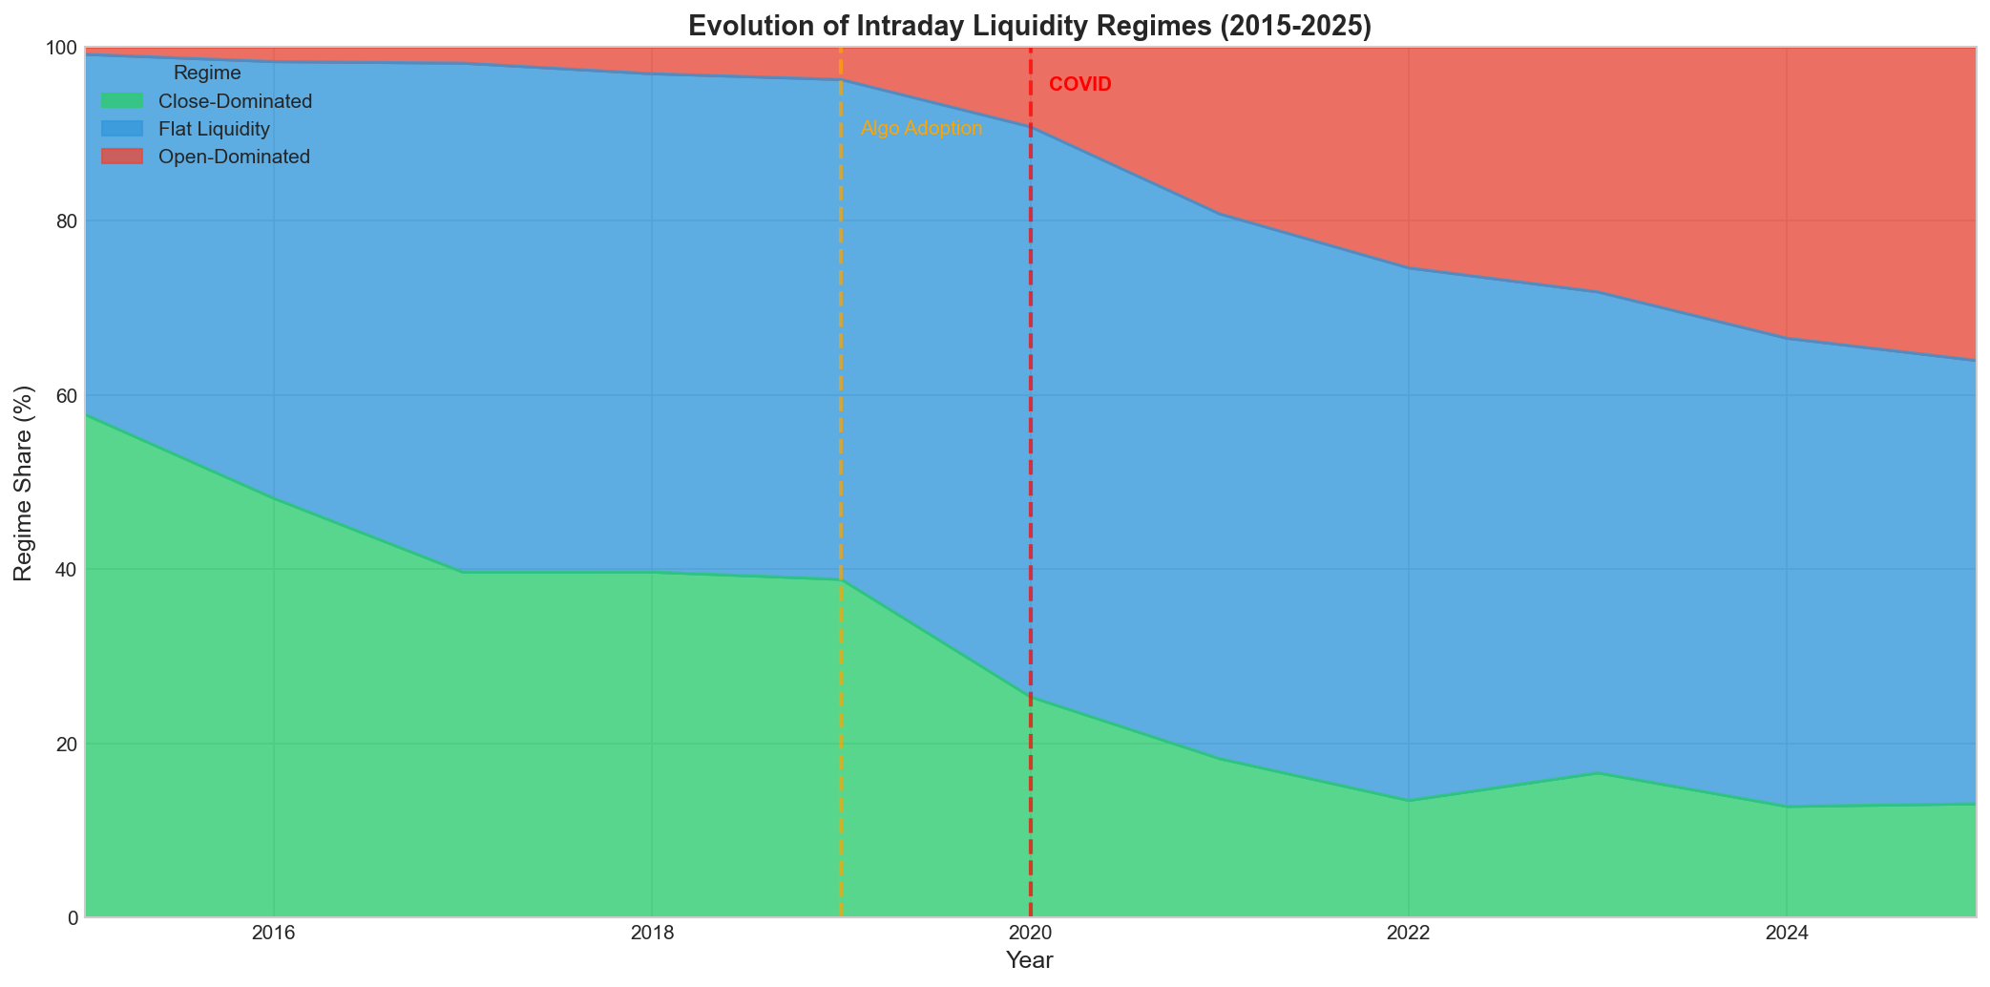

4.2 Structural Break Tests
To formally assess whether the observed changes constitute statistically significant structural shifts, we conduct chi-squared tests comparing regime distributions across subperiods. We focus on three economically meaningful intervals: a pre-2019 period, a transition period around 2019–2020, and a post-COVID period.
Across all pairwise comparisons, we reject the null hypothesis of equal regime distributions at the 1% significance level. Test statistics are large in magnitude, indicating that changes in regime composition are not driven by random fluctuations but reflect a fundamental transformation in intraday liquidity structure.
These findings provide strong evidence that Indian equity markets underwent a structural liquidity reorganization beginning around 2019, which accelerated during and after the COVID-19 period. 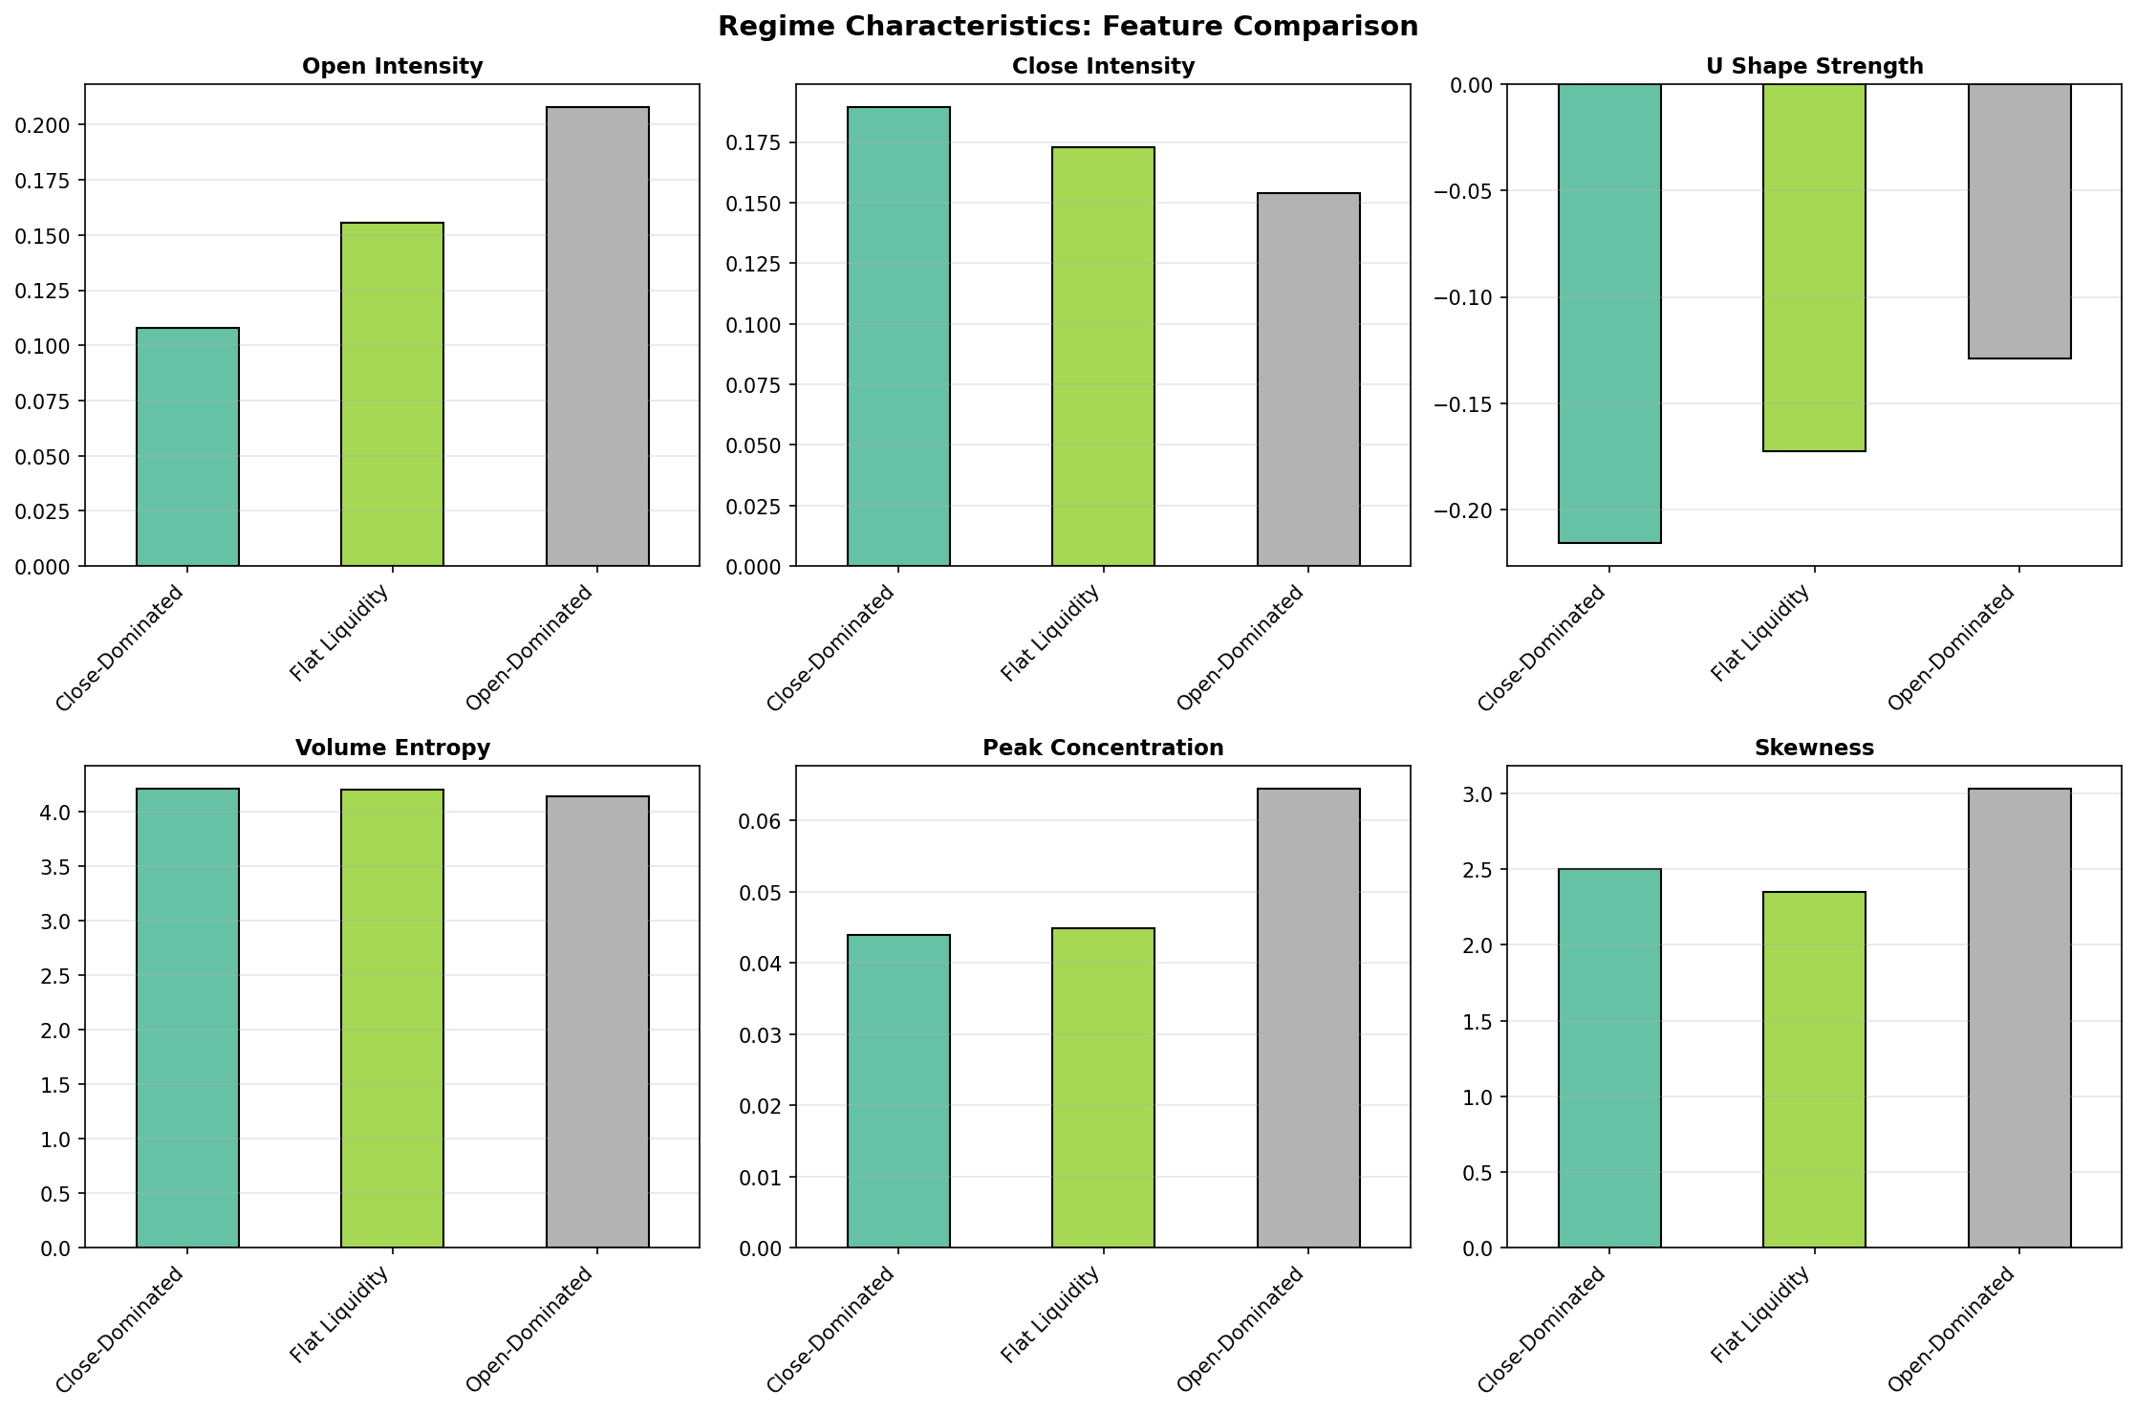

4.3 Regime Evolution Within Market Capitalization Buckets
One potential concern is that the observed regime shifts may be driven by changes in index composition or differences in trading behavior across firm sizes. To address this issue, we repeat the analysis separately for large-, mid-, and small-cap stocks.
The results show that the decline in close-dominated liquidity and the rise of flat and open-dominated regimes persist within each capitalization bucket. Small-cap stocks exhibit the most dramatic transformation, with open-dominated liquidity increasing sharply in the post-COVID period. Mid-cap stocks transition primarily toward flat liquidity, while large-cap stocks show a gradual but persistent move away from close-dominated trading.
These findings indicate that the structural evolution of intraday liquidity is systemic and not driven solely by shifts in market capitalization or index membership.

4.4 Regime Persistence and Transition Dynamics
To assess the stability of liquidity regimes, we examine year-over-year transitions in regime assignment at the stock level. Table 4 presents the estimated transition matrix.
Liquidity regimes exhibit substantial persistence. Flat liquidity is the most stable regime, with nearly 80% of observations remaining in the same regime from one year to the next. Open- and close-dominated regimes also display strong persistence, though at slightly lower levels.
Transition probabilities reveal a clear asymmetry. Direct transitions between open-dominated and close-dominated regimes are extremely rare. Instead, regime changes typically occur through the flat liquidity regime, suggesting an evolutionary path from end-of-day concentration toward continuous execution and, in some cases, front-loaded trading.
This transition structure is consistent with gradual changes in execution technology and trading preferences rather than abrupt shifts in behavior.
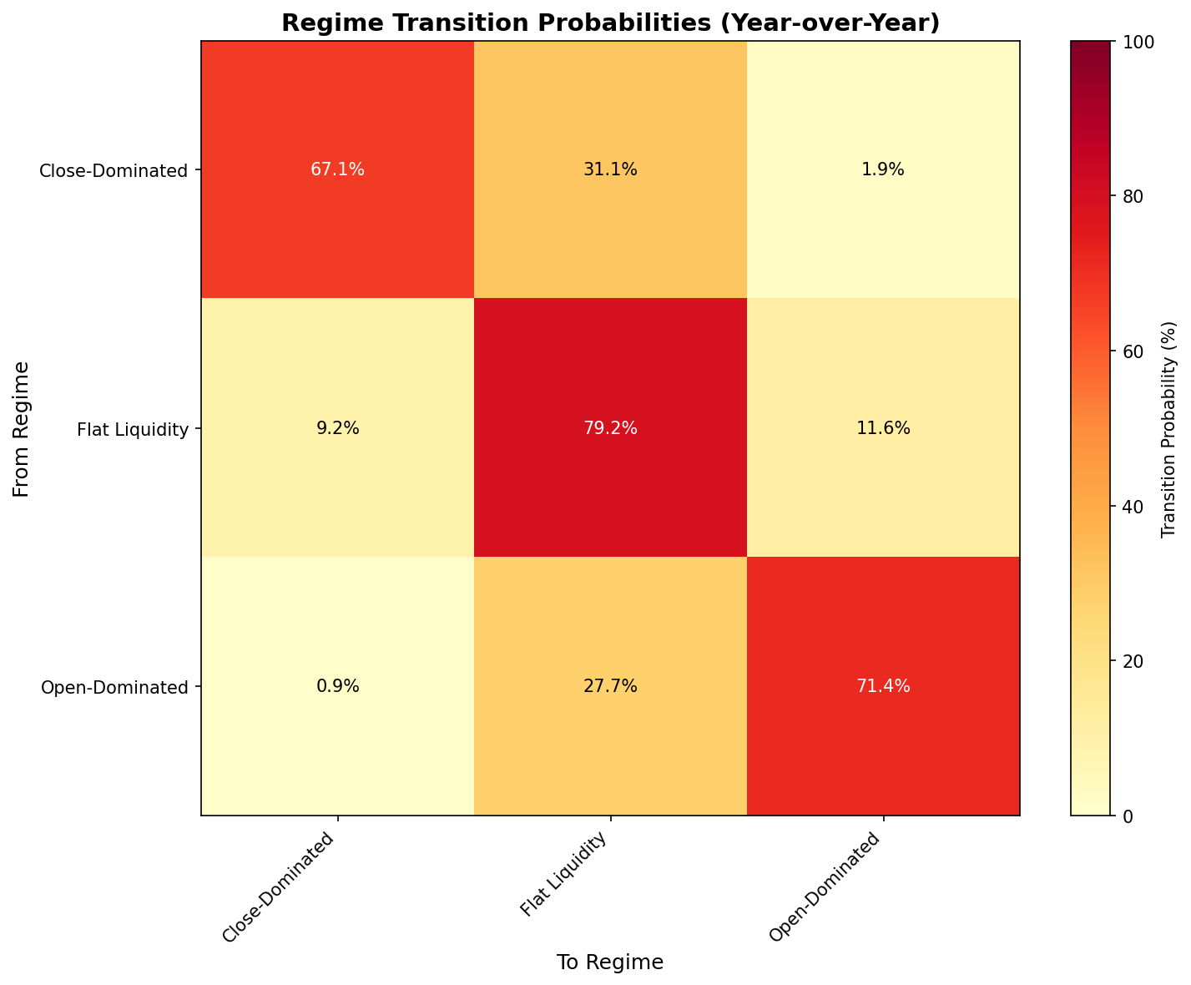
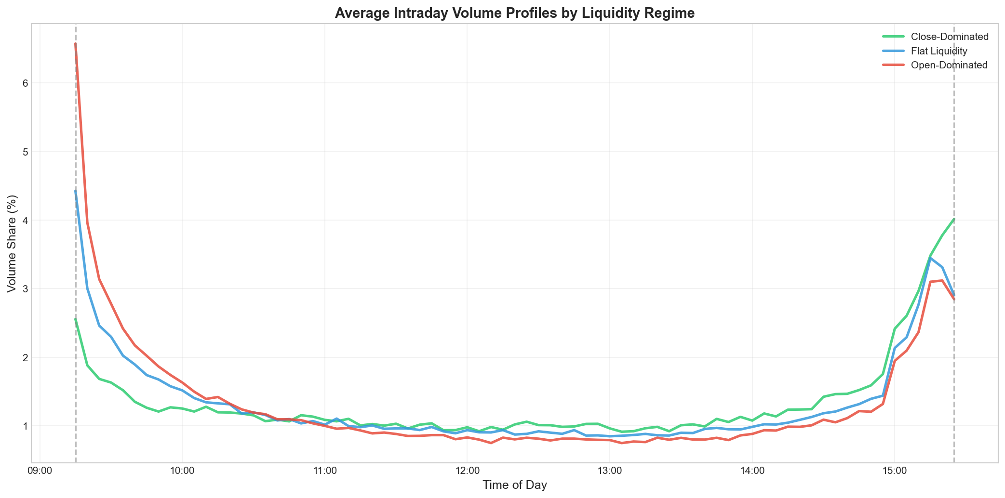

4.5 Stress-Day Liquidity Reallocation
We next examine how intraday liquidity regimes respond to periods of elevated market stress. Stress days are defined as those falling in the top 5% of daily realized volatility for the NIFTY 500 index.
Figure 4 compares average intraday volume profiles on stress days and normal days. During periods of high volatility, liquidity exhibits a systematic shift toward the market open. Open-period volume shares increase, while close-period concentration declines sharply. Correspondingly, the overall U-shape of intraday trading weakens on stress days.
Correlation analysis confirms that years with a higher fraction of stress days are associated with flatter intraday liquidity profiles and reduced close concentration. These results suggest that, during periods of heightened uncertainty, market participants accelerate execution earlier in the trading day, consistent with increased information urgency and a desire to reduce end-of-day exposure.

4.6 Discussion
Taken together, the results in this section document a structural evolution in intraday liquidity that is both persistent and economically meaningful. The Indian equity market has transitioned away from a regime dominated by end-of-day trading toward one characterized by continuous and, increasingly, front-loaded execution.
This evolution is evident across firm sizes, robust to alternative specifications, and amplified during periods of market stress. The findings are consistent with broader trends in electronic trading, algorithmic execution, and changes in investor behavior, while avoiding strong causal claims.

4.7 Summary
This section shows that intraday liquidity regimes in Indian equities are not static. Instead, they evolve systematically over time, exhibit strong persistence, and respond predictably to market stress. These patterns set the stage for the analysis in the next section, which examines the economic implications of liquidity regimes for execution costs and short-horizon price dynamics.
5. Execution Costs and Regime-Conditional Price Dynamics
This section examines whether intraday liquidity regimes have economic consequences for market participants. We focus on two related dimensions: (i) the feasibility and cost of executing trades under realistic participation constraints, and (ii) the short-horizon price dynamics associated with each liquidity regime.

5.1 VWAP Execution Feasibility and Slippage
To assess execution performance across liquidity regimes, we simulate a participation-constrained VWAP execution strategy using 5-minute prices and volumes. The strategy executes a fixed fraction of available volume in each interval, subject to upper participation limits designed to reflect realistic institutional trading constraints.
Execution cost is measured as the difference between the simulated execution price and the arrival price at the start of the trading day. Costs are expressed in basis points.
Regime-level execution outcomes
The results reveal clear differences across liquidity regimes:
- Flat liquidity regimes exhibit the lowest average execution costs, reflecting the availability of consistent liquidity throughout the trading session.
- Open-dominated regimes display slightly higher execution costs, driven by front-loaded volume concentration and early-session price impact.
- Close-dominated regimes frequently render VWAP execution infeasible under participation constraints, as a disproportionate share of liquidity is concentrated near the market close.
For close-dominated stocks, meaningful execution prior to the final trading interval often requires participation rates that exceed imposed constraints, leading to unstable or undefined VWAP outcomes. Rather than reflecting data limitations, this infeasibility highlights the execution fragility associated with extreme end-of-day liquidity concentration.
Interpretation
These findings imply that intraday liquidity structure directly affects execution strategy viability. Flat liquidity regimes are most conducive to low-impact execution, while close-dominated regimes expose traders to heightened benchmark risk and limited flexibility. Open-dominated regimes occupy an intermediate position, where early execution is feasible but may incur greater temporary price impact.

5.2 Liquidity Regimes and Short-Horizon Return Reversals
We next investigate whether liquidity regimes are associated with differences in short-horizon price behavior. Specifically, we examine lag-1 intraday return autocorrelations and the frequency of extreme price reversals following large return realizations.
Return autocorrelation
Across all regimes, intraday returns exhibit negative first-order autocorrelation, consistent with temporary price pressure and bid–ask bounce effects. However, the magnitude of reversal differs markedly by regime:
- Close-dominated regimes show the strongest negative autocorrelation, indicating pronounced short-term reversals.
- Open-dominated regimes exhibit moderate reversals.
- Flat liquidity regimes display the weakest reversal effects.
These patterns suggest that close-dominated trading is associated with the highest degree of non-informational price pressure.
Extreme reversals
We further analyze the probability that large intraday price moves are followed by reversals of opposite sign. Consistent with the autocorrelation results, extreme reversals are most frequent in close-dominated regimes and least frequent in flat liquidity regimes.
Economic interpretation
The strong reversal behavior observed in close-dominated stocks is consistent with non-informational trading motives, such as benchmarking, index replication, and inventory rebalancing near the market close. These activities generate temporary price pressure that is subsequently corrected. In contrast, flat liquidity regimes are associated with smoother execution and more efficient price formation, resulting in weaker reversals.

5.3 Linking Liquidity Structure, Execution, and Pricing
Taken together, the execution and return-dynamics results provide a coherent economic interpretation of intraday liquidity regimes:
- Execution efficiency is highest when liquidity is evenly distributed throughout the day.
- Execution fragility arises when liquidity is concentrated in narrow time windows, particularly near the close.
- Temporary price pressure and reversals are strongest in regimes dominated by non-informational trading.
These findings reinforce the view that intraday liquidity structure is not merely a descriptive feature of trading activity, but a key determinant of execution outcomes and short-horizon price dynamics.

5.4 Implications
The results in this section have several practical implications:
- For traders and asset managers, liquidity regime identification can inform execution timing and strategy selection.
- For risk managers, regime-dependent reversals highlight the importance of intraday exposure management.
- For market designers and regulators, the decline of close-dominated liquidity suggests a reduced concentration of end-of-day risk, potentially enhancing market stability.

5.5 Summary
This section demonstrates that intraday liquidity regimes have economically meaningful implications for both execution costs and price behavior. Flat liquidity regimes are associated with superior execution outcomes and more efficient pricing, while close-dominated regimes exhibit execution infeasibility under realistic constraints and the strongest short-horizon return reversals. These findings underscore the importance of accounting for intraday liquidity structure in both empirical asset pricing and practical trading applications.
6. Conclusion
This paper studies the structure and evolution of intraday liquidity in Indian equities using ten years of 5-minute data for NIFTY 500 stocks. Moving beyond the conventional assumption of a universal U-shaped intraday trading pattern, we document the existence of distinct and persistent intraday liquidity regimes characterized by open-dominated, flat, and close-dominated trading activity.
Our analysis reveals a pronounced structural transformation in intraday liquidity since 2019. The dominance of close-concentrated trading has weakened substantially, while flat and open-dominated liquidity regimes have become increasingly prevalent. This shift persists within market capitalization buckets and is robust to alternative specifications, indicating that it reflects a systemic evolution in market structure rather than compositional changes in the index. During periods of elevated market stress, liquidity reallocates toward the market open, further flattening intraday trading profiles and reducing end-of-day concentration.
Beyond documenting these patterns, we show that intraday liquidity regimes have economically meaningful implications. Flat liquidity regimes are associated with the lowest execution costs under participation-constrained VWAP strategies, while close-dominated regimes render such execution infeasible due to extreme end-of-day concentration. Moreover, close-dominated stocks exhibit the strongest short-horizon return reversals, consistent with concentrated non-informational trading pressure near the market close. In contrast, flat liquidity regimes display weaker reversals and more efficient intraday price formation.
Taken together, our findings suggest that intraday liquidity structure plays a central role in shaping execution outcomes and short-horizon price dynamics. The observed transition toward flatter and more front-loaded liquidity profiles points to the growing importance of continuous execution and electronic trading mechanisms in an emerging market setting.
This study contributes to the market microstructure literature by providing large-scale, high-frequency evidence on the evolution of intraday liquidity in Indian equities. It also offers practical insights for traders, asset managers, and regulators concerned with execution quality, intraday risk management, and market stability. Future research could extend this framework by incorporating order-book data, examining the interaction between liquidity regimes and algorithmic order flow, or exploring the implications of regime shifts for intraday asset pricing and volatility forecasting.

